ROAD ACCIDENT REPORT UK 2022, SQL QUERIES
CY Casualties:
SELECT SUM(number_of_casualties) as CY_Casualties
FROM [road_accident (1)]
WHERE YEAR(accident_date) = '2022'
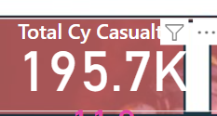

CY Accident
SELECT count (DISTINCT accident_index) as CY_Accidents
FROM [road_accident (1)]
WHERE YEAR(accident_date) = '2022'
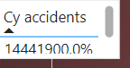

CY Fatal Casualties:

SELECT sum(Number_of_casualties) as CY_Fatal_Casualties
FROM [road_accident (1)]
WHERE YEAR(accident_date) = '2022' AND accident_severity = 'Fatal'

2855
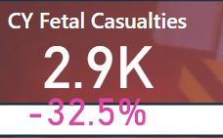
CY Serious Casualties:
SELECT sum(Number_of_casualties) as CY_Serious_Casualties
FROM [road_accident (1)]
WHERE YEAR(accident_date) = '2022' AND accident_severity = 'Serious'

27045 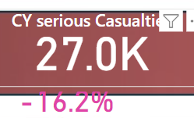

CY Slight Casualties:

SELECT sum(Number_of_casualties) as CY_Slight_Casualties
FROM [road_accident (1)]
WHERE YEAR(accident_date) = '2022' AND accident_severity = 'Slight'

165837

CASUALTIES BY VEHICLES

(Not able to achieve results as it was displaying error code)

SELECT * FROM [road_accident (1)]
SELECT
CASE
WHEN vehicle_type IN ('Agriculture vehicle') THEN 'Agriculture'
WHEN vehicle_type IN ('Car', 'Taxi/Private hire car') THEN 'Cars'
WHEN vehicle_type IN ('Motorcycle 125cc and under', 'Motorcycle 50cc and under', 'Motorcycle over 125cc and up to 500cc', 'Motocycle over 500cc','Pedal cycle') THEN 'Bike'
WHEN vehicle_type IN ('Bus or Coach (17 or more pass seats)', 'Minbus (8-16 passenger seats)') THEN 'Bus'
WHEN vehicle_type IN ('Goods 7.5 tones mgw and over', 'Goods over 3.5t. and 7.5t.', 'Van / Goods 3.5 tonnes mgw or under') THEN 'Van'
ELSE 'Other'
END As vehicle_group,
Sum(Number_of_Casualties) as CY_Casualties
FROM [road_accident (1)]
WHERE YEAR(accident_date) = '2022'
GROUP BY
CASE
WHEN vehicle_type IN ('Agriculture vehicle') THEN 'Agriculture'
WHEN vehicle_type IN ('Car', 'Taxi/Private hire car') THEN 'Cars'
WHEN vehicle_type IN ('Motorcycle 125cc and under', 'Motorcycle 50cc and under', 'Motorcycle over 125cc and up to 500cc', 'Motocycle over 500cc', 'Pedal cycle') THEN 'Bike'
WHEN vehicle_type IN ('Bus or Coach (17 or more pass seats)', 'Minbus (8-16 passenger seats)') THEN 'Bus'
WHEN vehicle_type IN ('Goods 7.5 tones mgw and over', 'Goods over 3.5t. and 7.5t.', 'Van / Goods 3.5 tonnes mgw or under') THEN 'Van'
ELSE 'Other'
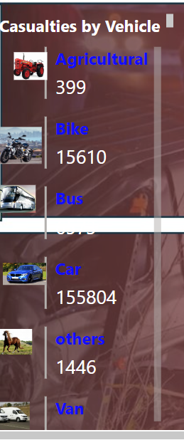
CY V PY Casualties:
CY Casualties

SELECT * FROM [road_accident (1)]
SELECT DATENAME(MONTH, Accident_date) AS Month_name, SUM(number_of_casualties) AS CY_Casualties
FROM [road_accident (1)]
WHERE YEAR(accident_date)= '2022'
GROUP BY DATENAME(MONTH, Accident_date)
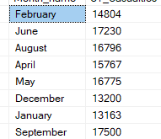
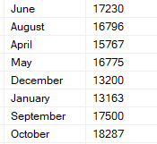
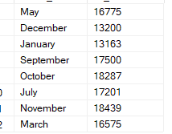
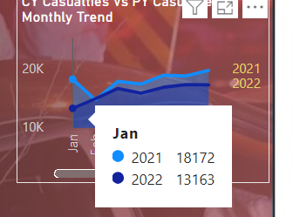

PY Casualties

SELECT * FROM [road_accident (1)]
SELECT DATENAME(MONTH, Accident_date) AS Month_name, SUM(number_of_casualties) AS PY_Casualties
FROM [road_accident (1)]
WHERE YEAR(accident_date)= '2021'
GROUP BY DATENAME(MONTH, Accident_date)

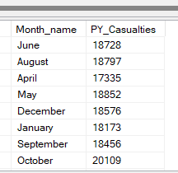
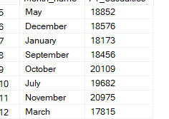
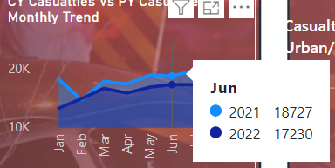

Casualties By Road Type:

SELECT Road_type, sum(number_of_casualties) as CY_Casualtes from [road_accident (1)]
WHERE YEAR(Accident_date) = '2022'
GROUP BY Road_type

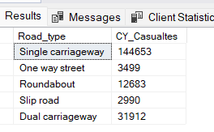
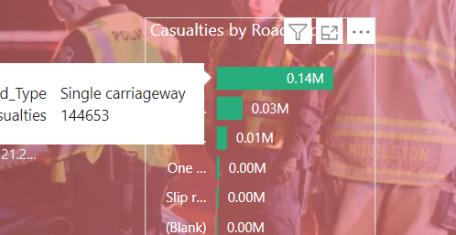
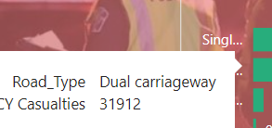

Casualties by Urban / Rural Area:
SELECT Urban_or_rural_area, SUM(number_Of_casualties) * 100 /
(SELECT SUM(Number_of_casualties) FROM [road_accident (1)] WHERE YEAR(Accident_date) = '2022')
FROM [road_accident (1)]
WHERE YEAR(accident_date) = '2022'
GROUP BY Urban_or_rural_area

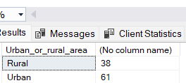
Casualties by Location :

SELECT * FROM [Road Accident Database].[dbo].[road_accident (1)]
SELECT local_authority, SUM(number_of_casualties) AS Total_Casualties
FROM [Road Accident Database].[dbo].[road_accident (1)]
GROUP BY local_authority
ORDER BY Total_Casualties DESC

